Items from Last Report:
- Prototype Testing: Filled the water tank and received real-time data. Calibrated the system for accurate pressure readings. Begun preliminary filtering analysis on data to reduce noise. Also assisted with pitot tube prototype which will be completed soon.
- Documentation: Created github repository for version control and documentation for future iterations. Can be viewed here
https://github.com/dlleong0017/Lateral-Line-System
Current Issues:
1. There are no issues.
Goals for Current Week:
1. Prototype Testing Cont.: Receive real-time data and attempt to reduce noise. Experiment with various conditions to verify vortex like creation in the water system.
Short Term Goal:
1. Conduct Testing: Undergo certain tests to validate the lateral-line system.
Long Term Goal:
- Sensor Signal System: The entire system will deliver a functional sensor and
decoder setup capable of outputting the clean signal required for fish wake data
analysis. July 30, 2026
Appendix
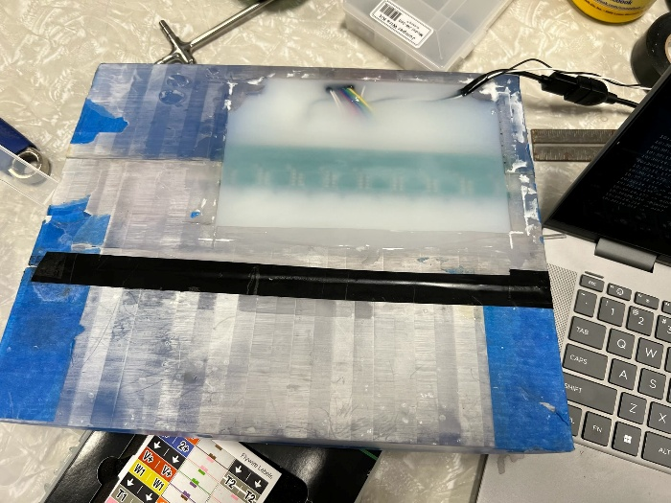
- Prototype Setup in casing:

